MineSweeper
Using the GridWorld framework as a tool, we can create a simple MineSweeper game. The class you will be building is Square, which you read about HERE.
I have created an extension of ActorWorld that takes advantage of the locationClicked and keyPressed methods that are built into GridWorld. Basically, every time a location is clicked the Actor in that space is told to act(). The world will then check to see if any Bombs have been placed on the grid, or if every Bomb is covered by a FlaggedSquare. To lay a flag down, hit the f key before you click and the runner will trade FlaggedSquares for Squares and vice versa.
The MineWorld code is posted here. I used only GridWorld so you should be able to understand roughly what I was doing. The locationClicked method is essentially the runner, and the rest of the methods are created to help me break the code into smaller parts.
View the hierarchy for MineWorld. Don’t be afraid, many of the classes are merely there so the will have different icons on the grid.
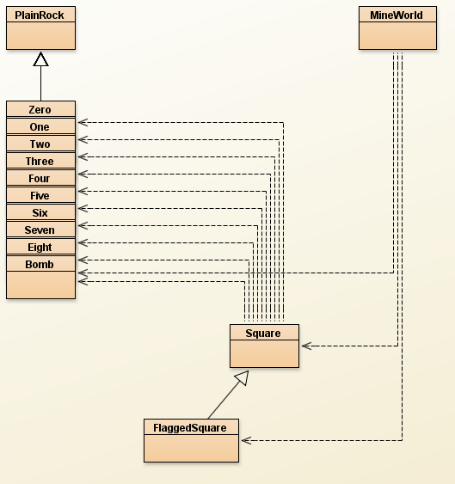
PlainRock: is a class that extends Rock( we want these to do nothing when they act ), but sets the Color to null, meaning there won’t be a Color over the icon
import info.gridworld.actor.Rock;

public class PlainRock extends Rock
{
public PlainRock()
{
setColor(null);
}
}

The classes Zero, One, Two, Three, Four, Five, Six, Seven, Eight, and Bomb all extend PlainRock and nothing else.
For example:
public class Zero extends PlainRock
{
}
And that’s it. We don’t need them to do anything, just sit there with the icon.
Once Square is written, extend it with FlaggedSquare. Once again, this extension is only so that the different class name will cause a new icon.
public class FlaggedSquare extends Square
{
public FlaggedSquare(boolean isABomb)
{
super(isABomb);
}
}

